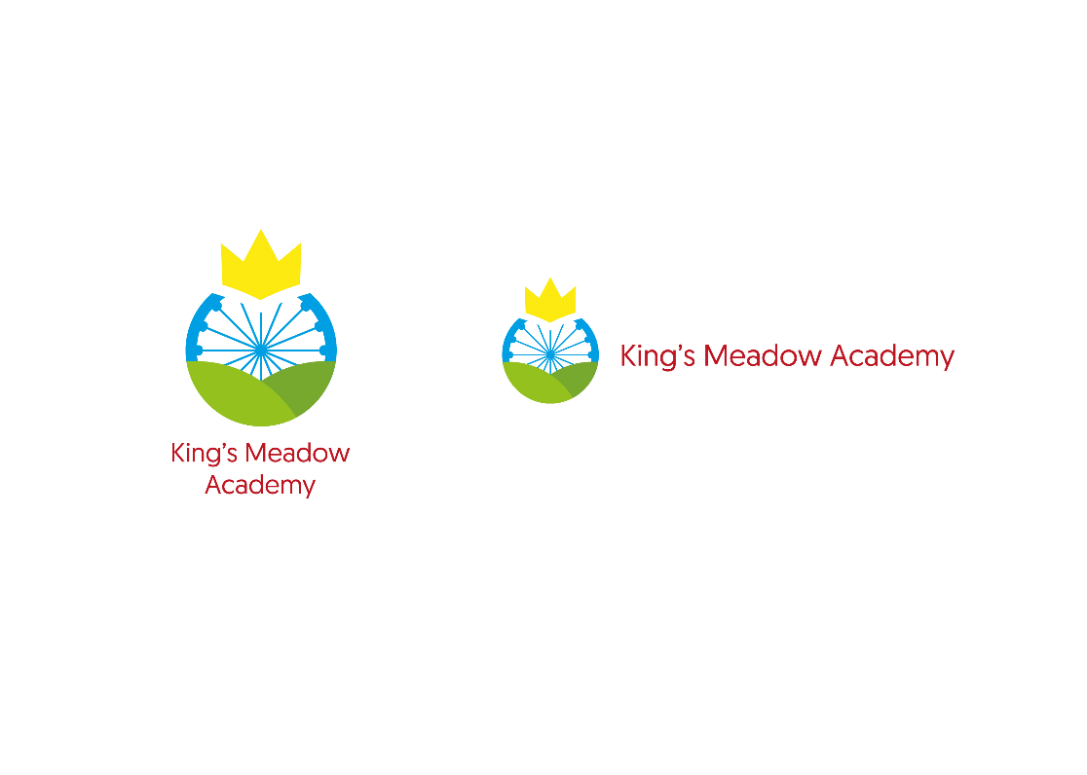**King’s Meadow Academy**

**Marking and Feedback Policy**

**Key principles**

The purpose of marking and feedback at King’s Meadow Academy is to further children’s learning and advance pupil’s progress. The marking and feedback should always be meaningful, manageable and motivating.

* Both verbal and written feedback will be evident in all classes (from KS1) in all subjects throughout the school. However, approaches may differ slightly depending on age, ability and topic.
* Immediate feedback (active marking) is shown to be the most effective, where children can respond and make progress immediately. There needs to be visible signs of improvements made.
* It is an expectation that children will be given time to reflect and respond to feedback so that pupils may act upon it and make improvements.

**Feedback and marking in practice**

It is vital that teachers evaluate the work that children undertake in lessons and use the information obtained from this to adjust their teaching.

Marking and feedback is most effective when completed in session or with the child present – if teachers take home lots of marking it gives children permission to make mistakes and leave it for the teacher to correct – if children are told within a session they have time to build on the feedback and improve their work they will begin to take responsibility for their own improvements.

There will be three effective forms of feedback given depending on the work set:

|  |  |  |
| --- | --- | --- |
| Type | What it looks like | Evidence (for observers) |
| Immediate | * Gathering and providing feedback from teaching (whiteboards, books etc.) * Takes place in lessons with individuals or small groups * Given verbally to pupils for immediate action * CT or TA provides support or further challenge * May re-direct the focus of teaching or the task * Annotations using the marking code | * Lesson observation / learning walks * Some evidence of annotations using the marking code showing an impact on the progress of learning. |
| Summary | * Often takes place at the end of the lesson or activity * Often involves the whole class or groups * Opportunity for evaluation of learning in the lesson * Self or peer assessment may occur against set criteria | * Lesson observation / learning walks * Evidence of self and peer assessments |
| Review | * Takes place away from the point of teaching * May include written comments for pupils to respond to * Opportunities for assessment of understanding * Leads to adapting future planning and grouping | * Acknowledgement of work completed * Written comments – specific praise and guidance for future learning * Adaption / annotation of planning |

**Marking codes**

THESE MUST BE AVAILABLE FOR ALL CHILDREN AND STAFF IN THE CLASSROOM.

Marking needs to be completed neatly with a **BLUE** pen.

It is assumed that marking is completed by the classteacher. Where this is not the case, a supply teacher or teaching assistant **MUST** initial at the side of the marked piece of work.

|  |  |
| --- | --- |
| Key Stage One | Key Stage Two |
| √  Success  Incorrect answer  Verbal Feedback  Punctuation  Spelling  Finger spaces        VF | √  Success  Incorrect answer  Verbal Feedback  Punctuation  Spelling  Finger space  New paragraph  Grammar  Word added      VF    ^ |

**Marking**

**It is not possible to consider every possible variation of marking as it will vary from year group to year group. We are looking to develop even practice and consistency across the school and will monitor and give feedback on this across 2020/21. To support staff with managing workload, the following may be a useful guide:**

|  |  |
| --- | --- |
| Subject | Minimum Expectations |
| Writing | To be marked daily linked to learning objective – use  to praise and to identify ‘next step’ errors for children to address Fix It Time (FIT). Consider creating time to do this within the session time for a group at least to reduce the marking load after the lesson. (verbal feedback shown by vf in the book)  In depth marking Minimum expectation at least once per half term. This will be linked to an assessment list for each year group. |
| Maths | To be marked daily linked to learning objective – use  to praise and to identify ‘next step’ errors for children to address Fix It Time (FIT). Consider creating time to do this within the session time for a group at least to reduce the marking load after the lesson. (verbal feedback shown by vf in the book) |
| Reading | Any work completed to be marked.  Where the marking has been undertaken in conjunction with pupils eg. following a discussion and looking at a mark scheme, this should be indicated. (see stickers) |
| Topic work (science, history, geography, RE, Art / DT) | Each piece of topic work should be marked. Marking in non-core subjects should focus on the subject specific skill being taught. Where applicable, staff may mark cross-curricular pieces for topic skills and as assessment pieces for English writing.  Some marking should contain and ; the should be addressed in FIT by pupils.  Marking should be looking at subject specific skills – for the most part try to give feedback about the subject rather than a comment on a generic skills (presentation) or an English skill. |
| The expectation is that objectives in non-core books state the subject within the objective for ease of scrutiny and evaluation by leaders.  These should take the following format:  Working as a historian, I can XXX  It is anticipated that sticking should be kept to a minimum and that, in the main, children should write on the pages of the book.  Pieces of work, regardless of subject, should be organised in date order to show progress in learning through the book. | |
| It needs to be acknowledged that some subjects generate little ‘permanent’ evidence of learning – the learning therefore becomes ‘invisible’ and is difficult to capture evidence of learning taking place. This is especially true of practical subjects eg. music and PE.  In addition, children may also:   * Use a speech bubble to explain how they have improved in PE/Music * Take a photograph / recording of an initial piece – give themselves and then repeat at the end of the unit   In order to further demonstrate progress in these areas the teacher may:   * Send a postcard home – (photocopy and add in to topic book / file) * Complete pre and post learning activities (see topic planning for individual subjects) * Complete a before / after assessment grid of skills to show improvement in a particular skill | |

**2020/21 Spellings must be addressed in all written work**.

To further support progress of pupils at King’s Meadow Academy, we need to consistently address spelling. This needs to be sensitive to the age / ability of the individual pupil. The ‘escalation’ for corrections would be to look at

* ‘Common Exception’ words / words from year group lists / spelling patterns taught
* Words that have been modelled by the teacher and contain errors
* Subject specific vocabulary that has been taught

In Key Stage 1: spellings will be corrected above the child’s writing

In Key Stage 2: a maximum of 5 spellings will be written out correctly below their piece of work.

**Children as markers**

Self-assessment: Children will have opportunities to check and edit their work before the end of the session.

Peer-assessment: This begins in Year 2 upwards with children giving positive praise and making suggestions about how a partner can improve their work. This will be shared between pupil and a partner verbally.

**Policy monitoring, review and evaluation**

Marking and feedback will be closely monitored by subject leaders, SLT and Governors through:

* Lesson observations / learning walks
* Book scrutiny
* Pupil discussion
* Moderation
* Extended pieces of written work or extended tasks will require written comments. These will allow children’s achievements to be recognised and provide further guidance for future learning. A star will include a brief comment, with precise and specific praise. A present will include a focused comment which should help the child ‘diminish the gap’ and provide guidance for future learning.

**Expectations of** **Presentation**

* All books to be labelled correctly on the front – full name, class and year group, subject.
* On the inside cover, a label should show prior attainment of the pupil in Reading, Writing and Maths.
* All work should be dated and have a title/learning objective - date stamps may be useful for some year groups.

NB: LOs can be prepared on stickers for children to save time or can be cut and glued in. This is maintain focus on the application of skill NOT copying objectives.

* Pencils and pens used in books should make neat and tidy marks. Ensure all pencils are sharp.
* A ruler must be used for all lines, including underlining.
* Handwriting to be the best the child is capable of achieving at all times – there should be consistency across all books the child uses.
* Writing to sit on the lines on the page.
* Writing to start at the margin or edge of page. Numbers to be written in the margin.
* No writing above top line or below bottom line on a page.
* No boxes, doodles or drawing on pages or covers of books.
* All crossing out to be done with just one line through – no scribbling.
* If work is on paper, the child’s name should be written neatly on the back – in top left hand corner of paper (to preserve directionality).
* Unacceptable presentation to be identified in line with marking code and to be repeated by the child in whole or part.

NB: The use of rubbers is at the teacher’s discretion as long as they do not distract from application, time management and overall presentation

(see also assessment overview for 2020/21)

Policy Written: June 2020

Formal Review: June 2021

This policy will be reviewed regularly by SLT, subject leaders and all staff to ensure that it is effective and workable. Mid-year changes to practice may be made and shared with staff within the academic year.