Statement of Intent for Reading and Phonics

We are determined that every pupil will learn to read at KMA and we aim for everyone to develop a life-long love of reading.
At KMA we recognise and value the importance of reading and reading for pleasure and how it empowers children throughout their school life and beyond. We believe that all our children deserve a rich curriculum which encourages extensive reading of whole books and other types of texts.
We aim to promote the concept of reading for pleasure and we ensure that we include a range of ‘real books’ within the Curriculum for English as well as the opportunity for sustained reading from a range of other self‐chosen fiction and non‐fiction texts from our school library. We have carefully planned progression with our texts so that children are building on key knowledge and skills in reading.
The table below shows how we
teach reading at King’s Meadow Academy
Learning the sounds | Developing reading skills | Independent reading | Wider Reading | Practising at home
 | 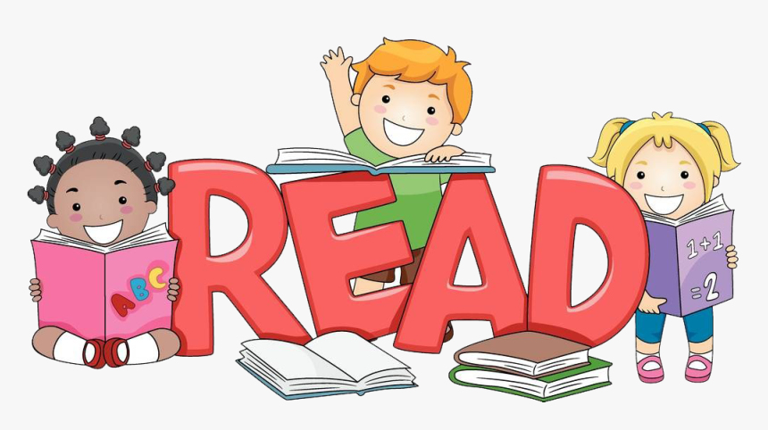 |  | 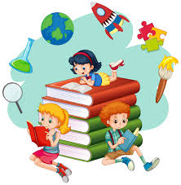 | 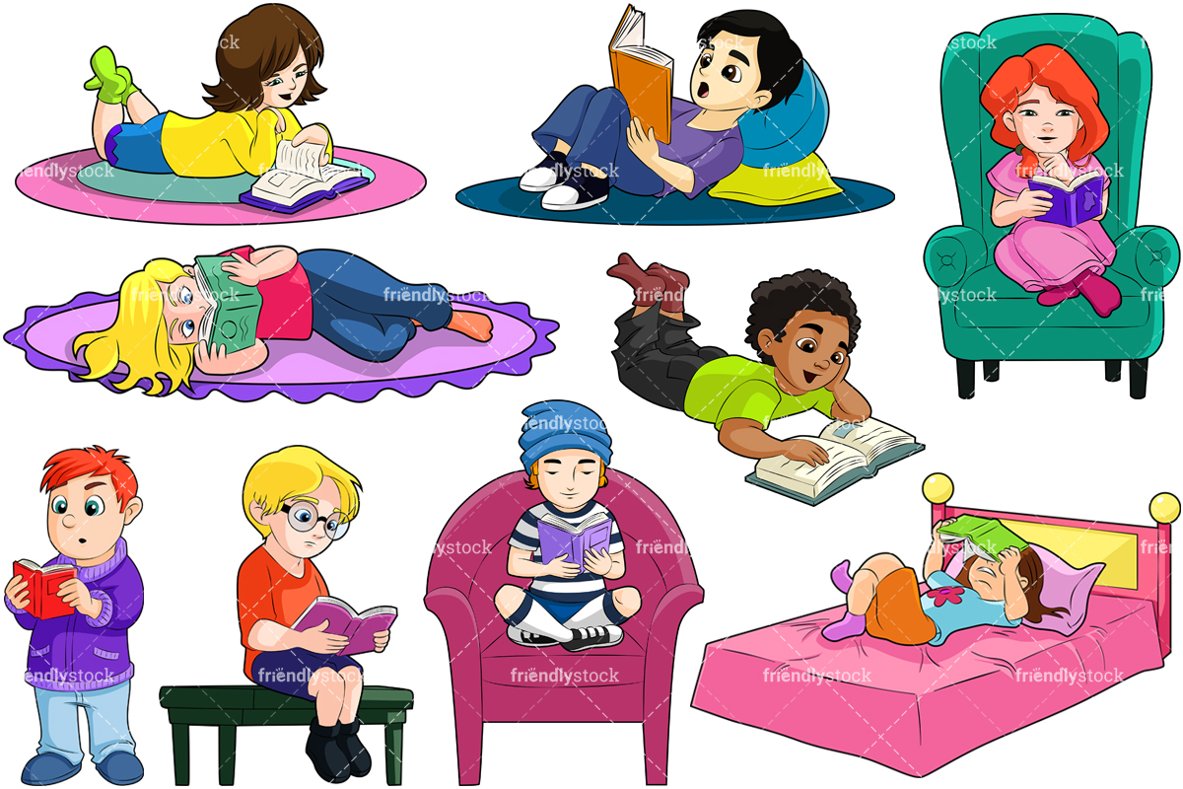
Read Write Inc phonics lessons  When children start in Reception and through to Key Stage 1, they will be taught how to read using the RWI programme. As they move through to Key Stage 2, children who need additional support and some new arriving pupil’s may need to have the sounds embedded using this programme | Modelled/Shared Reading Lessons  In these lessons we teach the children comprehension skills of predicting, retrieval, inference and deduction. We teach them how to try and understand what new words mean and encourage them to use all these skills to understand the text. | Becoming an independent reading  AR has been adopted by the school to encourage and improve reading, measure growth of the individual reader and provide quality reading for all. It allows for personalised learning targets to be set up and for progress to be easily monitored. | Reading in other subject areas  Children have opportunities to read other subjects such as History, R.E. and Science. They use this information within their lessons or as part of their projects. | Home reading books  Each week children will bring home reading materials to practise reading at home. In Reception and Key Stage 1 these books will have been read at school first. Books in Key Stage 2 will be linked directly to their reading age to make sure the readability level and the content is appropriate.

Statement of Implementation for Reading and Phonics

This Photo by Unknown Author is licensed under CC BY-SA
This Photo by Unknown Author is licensed under CC BY-SA
Reading is the key to learning

King’s Meadow Academy identifies two important phases in reading development:
- learning to read
- reading to learn.
We want our children to be able to read quickly and effectively so that they can access all areas of learning across the curriculum
Our reading curriculum is shaped by our curriculum intent which aims to enable all children, regardless of background, ability or additional needs, to flourish to become the very best version of themselves they can possibly be.
Reading is an essential life skill:
- providing access to the experiences of people from different cultures and times.
- Enabling children to develop knowledge and skills that are transferrable to other curriculum areas.
At King’s Meadow Academy children are encouraged to encounter and be challenged by ideas from their experiences which they would not normally be exposed to beyond their own community.
We believe reading is a fundamental part of communication in an ever more connected world, an ability to not only read but understand the intention of others is essential as they progress into the next stage of their learning.

Guidelines for reading
At KMA, we recognise the importance of taking a consistent whole school approach to the teaching of reading to ensure a love of reading and the highest achievement in reading for each child.
The teaching of reading is carefully planned to meet the needs of all of our children taking into account the literacy baselines and home support.
In each phase, teaching strategies are employed to recognise different individual children’s needs through providing:
- positive attitudes to reading, which are fostered through carefully designed teaching activities and classroom provision.
- Emphasise the importance of reading and encourage pupils to read at home with their parents, through reading celebrations such as World Book Day.
- A balanced approach: promoting children’s abilities to decode written language at word and sentence level, and to search for meaning in the text. Encouraging pupils to engage imaginatively with texts, empathise with characters and develop their specific interests in the world around them through their reading.
- Strategies to teach reading both inside and outside the English lesson, providing meaningful contexts to read

Strategies used
- Phonics
KMA uses a systematic, synthetic phonics approach to teach reading; following the programme Read Write Inc.
Fidelity to one scheme ensures that the teaching of reading in our school is consistent, effective and that irregular words are fully learnt.
Phonics teaching will be used to provide a rigorous, systematic framework in which to teach pupils to hear the 44 English speech sounds, blend them together into words and segment words into sounds for writing.
Teachers follow the handbook guidance carefully to organize the teaching sessions; they use partner work; Fred talk and Fred fingers etc. See policy ‘Teaching of phonics, reading and writing in EYFS and KS1’ for more information about how this is taught in Early Years and Key Stage 1.
- Modelled Reading
“Research indicates that shared reading typically improves students’ reading achievement” (Routman, 2003, p.130).
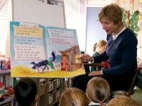
Shared reading provides the opportunity to:
- Develop students’ love of reading
- Build self-esteem and self-efficacy and develop students’ confidence as readers
- Explicitly teach reading strategies and skills
- Provide a risk-free, safe reading environment in which students can continue to build and develop their reading strategy toolkit
- Empower students to deepen their comprehension
- Enhance oral language development
- Expose students to a wide range of genres, text-types, and forms to help them enjoy rich, authentic, interesting texts that are above the average independent reading level of the class
- Support all students at all reading levels. Each student will participate in reading and discussing at his/her individual level of ability and benefits from listening to and learning from others while being supported by the teacher LEVEL OF TEACHER SUPPORT
- Revisit and re-read texts which can significantly benefit all students regardless of their reading abilities as texts become familiar and portions of the text are closely examined for implicit messages
Teachers in KS1 provide on average three, fifteen-minute sessions of modelled reading each week.
- Whole Class Guided Reading (WCGR) Pupils who have learned to decode text are at the reading to learn stage.
Pupils are taught to apply comprehension skills through whole class guided reading (WCGR) or RWI or Fresh Start accordingly.

WCGR is planned carefully to explicitly teach reading strategies using the following domains:

1. Background Knowledge
2. Read Aloud, Think Aloud
3. Visualise
4. Clarify
5. Inference
6. Summarise and synthesise

The above are taught strategically using high quality texts (see the Reading Spine), focusing on one specific element within each WCGR session.

Each half term pupils will be taught the following:
- 2-3 weeks fiction
- 2 weeks non-fiction
- 1 week poetry

Fiction, non-fiction and poetry will link to a theme to enable children to make connections and deepen their knowledge and understanding of texts.

- Independent Reading
Independent reading will be used to:
- Promote enjoyment of reading;
- Promote the development of independent learning strategies;
- Provide a context for the application of skills and knowledge about reading.
Children who have completed the RWI programme access books through Accelerated Reader to encourage and improve reading, measure growth of the individual reader and to provide quality reading for all. It allows for personalised learning targets to be set up and for progress to be easily monitored.
Every child taking part in AR will complete a STAR reading test at the beginning of the year and at the end of each half-term. It is a twenty-minute multiple choice reading assessment completed individually on the computer. Questions continually adjust to your child’s responses so if their response is correct, the difficulty level is increased. If they miss a question or give an incorrect answer, the difficulty level is reduced.
The STAR reading test, along with teacher judgement assists us in identifying a child’s ZPD (Zone of Proximal Development) range.

Shared Reading
We do it together
(Teacher scaffolds and supports)
- Text visible for all children
- Text revisited
- Active participation
- What proficient readers do

Independent Reading
You can do it alone
(Teacher observes)
- Independent application of proficient reading strategies
- Transfer learning to a new situation
Modelled Reading
I do it, you watch it
(Teacher demonstrates)
- Read aloud
- ‘Think aloud’
- What proficient readers do

High
Level of teacher support

Reading across the curriculum
At King’s Meadow Academy texts are selected that contain subject specific vocabulary to ensure that children become familiar with technical and unusual vocabulary (Tier 2 and 3 words). This enables pupils to be better prepared to access the Key Stage 3 curriculum. Vocabulary is a thread that runs through every subject area, it is identified and explained using techniques to help children develop a rich and varied language store.

Reading for Pleasure

The active ingredients for promoting a positive reading culture are non-negotiable and must be inherent throughout school.
To promote a positive reading culture King’s Meadow Academy will include:
Teacher knowledge of children’s literature to enrich and widen experiences and pleasure in reading
Children’s experiences – fostering children’s autonomy as readers
Reading environment – King’s Meadow Academy creates a relaxed and informal ethos with reading, including reading areas and library, teachers reading aloud daily, dedicated reading time, book-talk, children as librarians
Teachers as readers - displays of teachers reading their favourite texts, assemblies with adults throughout school reading (lunchtime supervisors, cleaners, teaching assistants etc)
Reading community – Reading relationships with families, supporting parents to read (National Literacy Trust), governors and parents reading to children in school, reading newsletter to be sent to parents termly celebrating the reading achievements within school

Resources for reading

At King’s Meadow Academy we ensure all children read widely across fiction and non-fiction including different genres, poetry, comics and texts that promote cross curricular links. Topic linked texts are included in our knowledge and skills-based curriculum, to enhance children's learning, particularly the development of their vocabulary skills. We have a well-stocked library for children to access to choose books and to access Star Reader.

To achieve our aim for everyone to develop a life-long love of reading at King’s Meadow Academy we:
- Expose the pupils to a stimulating range of books and texts, fiction / non-fiction / poetry / play scripts.
- Provide a range of reading experiences, individual reading / shared reading /guided reading / class reading / class stories and poetry / use of school and class libraries.
- Involve parents as much as possible.
- Ensure reading is structured and enjoyable.
- Use record keeping and assessment to monitor progress.
- Provide support for pupils with Special Educational Needs as appropriate
- Provide stimulating texts which are age related with appropriate graduated vocabulary.
- Encourage independence through the development of a variety of skills.
Working in Partnership with Parents
At King’s Meadow Academy we want to encourage every child to read with a grown up at home every night. Children who read with their families grow in confidence much more quickly and develop a love of reading that can last a lifetime. In recognition of the important role parents have we hope our home/school reading initiatives will motivate children to read at home whilst earning 'rewards' for their efforts.

