Our policy for children’s school uniform is based on the belief that:
- A school uniform promotes a sense of pride in the Academy
- Creates a feeling of community and belonging
- Raises the profile of the Academy within in the local community
and beyond
- Is practical and smart
- Identifies the children within our Academy
- Makes children feel equal to their peers in terms of appearance as everyone has the same

We appreciate parental support to uphold the uniform policy.
This year, there has been some relaxation to our uniform policy in light of the Covid pandemic having impact on availability and access to some items.
From September 2021, we will be working to the requirements of our uniform policy. We have shared these expectations below and trust that you can source the appropriate items during the school holidays.

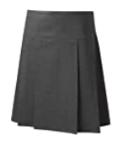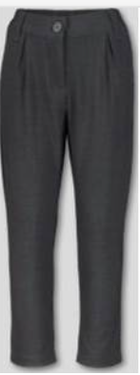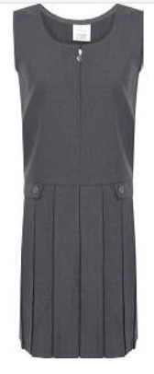 | Grey trousers  Grey pinafore  Grey skirt
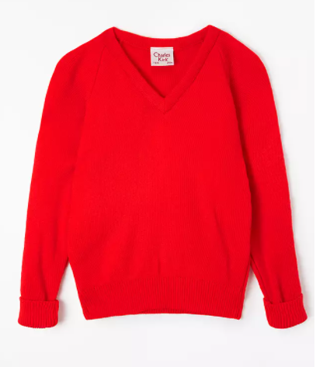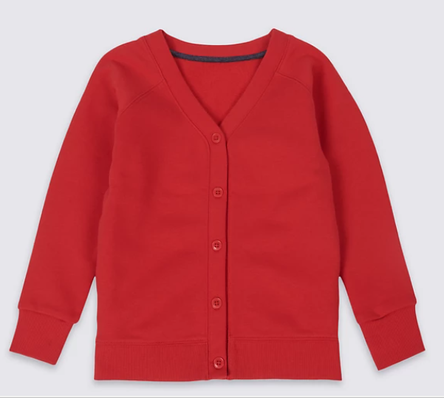 | Plain red school jumper or plain red school cardigan.  School sell red jumpers (£6.50) and cardigans (£7.00) bearing the school logo.  These may be hand knitted if preferred.
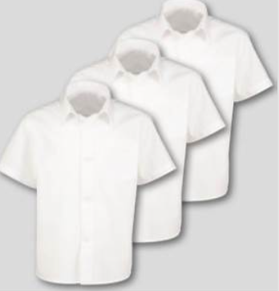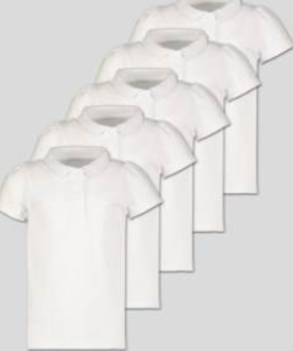 | White school shirts or polo shirts
Grey, black or white socks
Grey or black tights
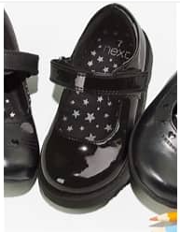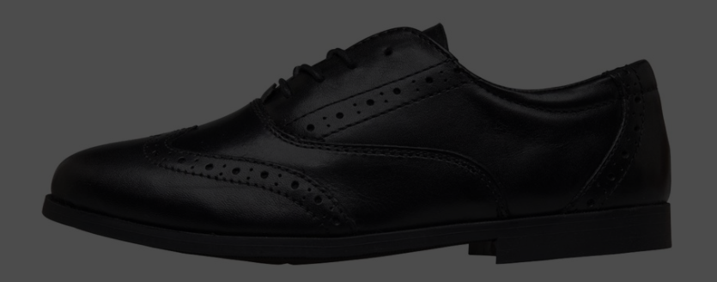 | Black school shoes.  Please bear in mind that the shoe should be practical for moving around school and playing outside. Children should be able to take these on and off independently so please select a fastening your child can manage on their own.  NB. These shoes should be a different pair to the ones children wear for PE.
PLEASE MAKE SURE THAT ALL ITEMS OF CLOTHING ARE CLEARLY NAMED.

For PE, children should change in to:
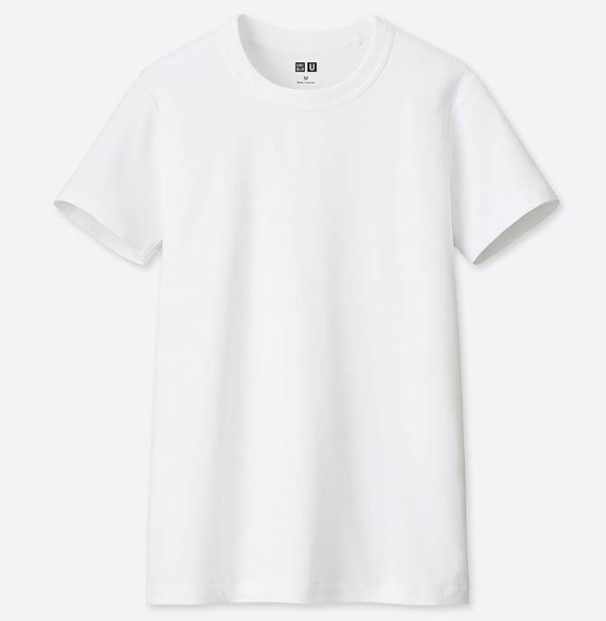 | White t shirt  A close fitting, round neck t-shirt is perfect
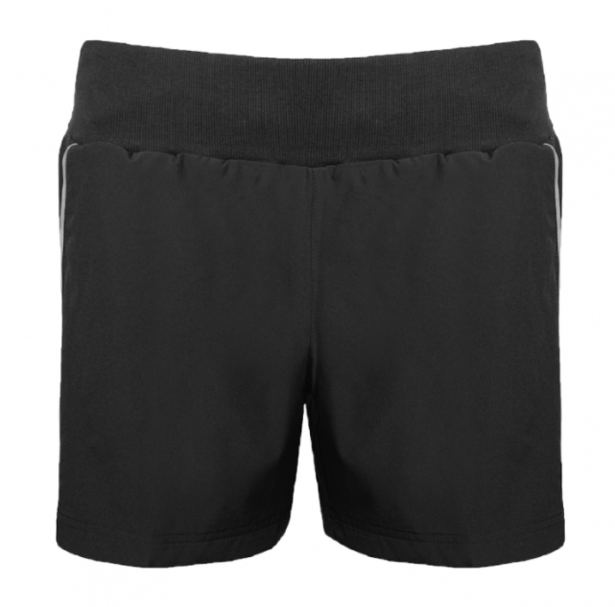 | Dark PE shorts
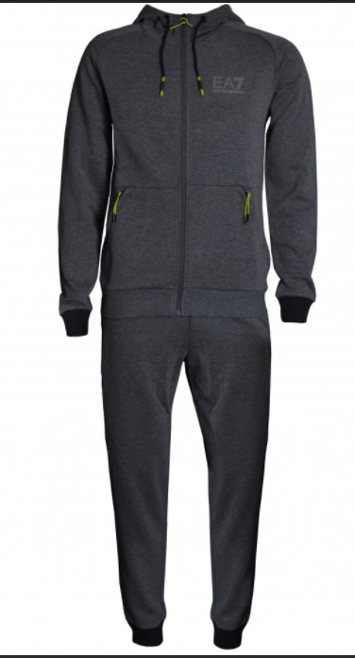 | Where possible, PE sessions will be held outdoors. For this, children may wear dark coloured joggers and top.
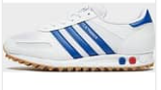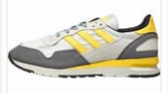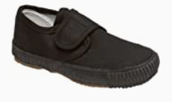 | Children should wear trainers or pumps for PE. This should be a change of footwear from the footwear that they wear to school each day.
PLEASE MAKE SURE THAT ALL ITEMS OF CLOTHING ARE CLEARLY NAMED.
Children will be asked to change back in to their uniform at the end of the school day.

Note: We do not have a preferred supplier for the items shown on this sheet. Items can be purchased at reasonable cost from local supermarkets.
We do have some limited stock of spare uniform in school that we can provide to families who are suffering hardship. Please call in and have a word with staff in the main office or the pastoral team if you are struggling to provide your child with school uniform.

