At Kings Meadow Academy our curriculum is designed so pupils will experience a broad and balanced offer from Reception to Year 6, which has weaved throughout it a wide range of experiences and opportunities to enable them to know more and remember more. Our curriculum is matched to both the EYFS and the National Curriculum. We believe that our pupils need a thorough programme of teaching and learning to embed the core skills of literacy, numeracy and oracy, alongside a cyclical subject based offer to prepare them for life within and beyond our school.
Our curriculum emphasises the importance of our 4 school values and our 8 pillars that support our children to enact these values. In addition, our curriculum design ensures there is an ambitious curriculum offer for all, regardless of their starting point.
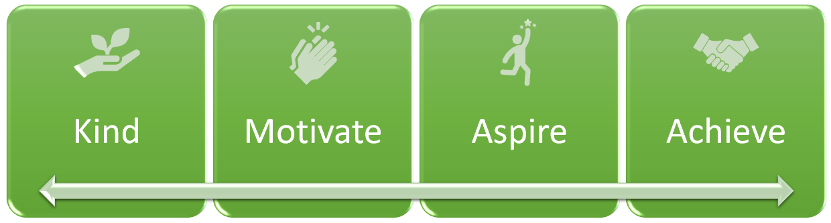

Concentrate | Work hard | Understand others | Improve | Don’t give up | Imagine | Push yourself | Try new things

Inclusion is at the heart of all we do as we ensure that our curriculum is accessible to all. We achieve this through ensuring that the curriculum is:
- Relevant to our context
- Made up of a range of collaborative learning opportunities
- Interactive
Through our curriculum we aim to motivate our pupils by making links between learning and providing real experiences that are memorable and help build effective learning schemas. By developing creativity, championing community links, promoting parent partnerships and sparking our pupils curiosity in a range of different subject disciplines, we aim to fulfil our vision of our school being a beacon rooted in the community, providing a signpost for those who need it, whilst upholding our school mission of developing:

“A school community full of happy children who are confident, independent and thoughtful”

