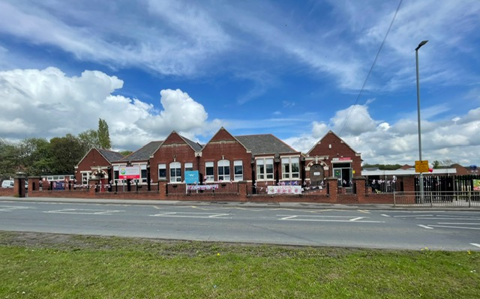

# King’s Meadow Academy Curriculum

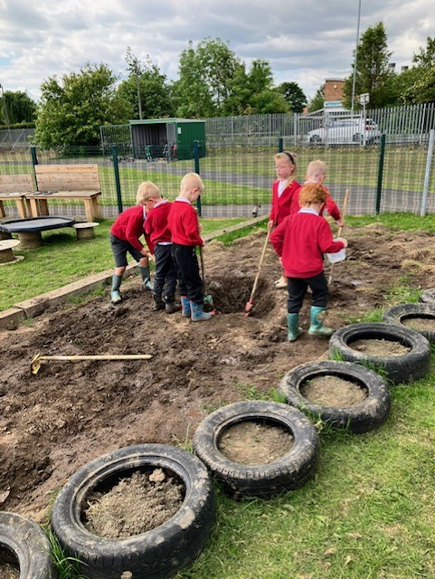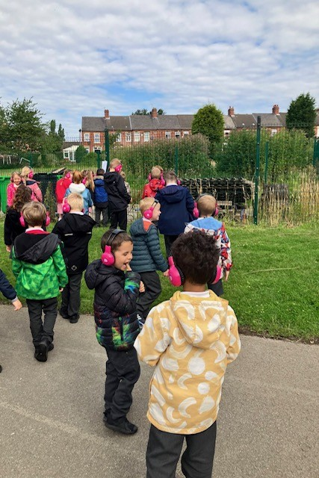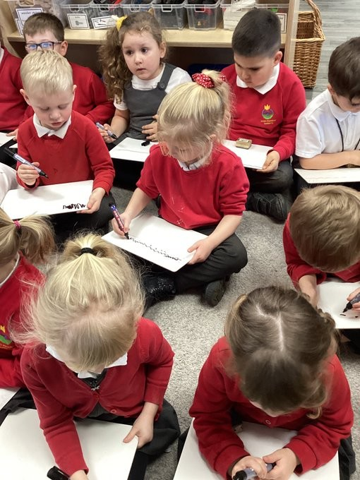

***“happy children who are confident, independent and thoughtful.”***

**At Kings Meadow Academy our curriculum is designed so pupils will experience a broad and balanced offer from Reception to Year 6, which has weaved throughout it a wide range of experiences and opportunities to enable them to know more and remember more. Our curriculum is matched to both the EYFS and the National Curriculum. We believe that our pupils need a thorough programme of teaching and learning to embed the core skills of literacy, numeracy and oracy, alongside a cyclical subject based offer to prepare them for life within and beyond our school.**

Our curriculum emphasises the importance of our 4 school values and our 8 pillars that support our children to enact these values. In addition, our curriculum design ensures there is an ambitious curriculum offer for all, regardless of their starting point.

|  |  |  |  |  |  |  |  |
| --- | --- | --- | --- | --- | --- | --- | --- |
| **Concentrate** | **Work hard** | **Understand others** | **Improve** | **Don’t give up** | **Imagine** | **Push yourself** | **Try new things** |

**Inclusion is at the heart of all we do as we ensure that our curriculum is accessible to all. We achieve this through ensuring that the curriculum is:**

* Relevant to our context
* Made up of a range of collaborative learning opportunities
* Interactive

Through our curriculum we aim to motivate our pupils by making links between learning and providing real experiences that are memorable and help build effective learning schemas. By developing creativity, championing community links, promoting parent partnerships and sparking our pupils curiosity in a range of different subject disciplines, we aim to fulfil our vision of our school being a beacon rooted in the community, providing a signpost for those who need it, whilst upholding our school mission of developing:

**“A school community full of happy children who are confident, independent and thoughtful”**

|  |  |  |  |  |  |  |
| --- | --- | --- | --- | --- | --- | --- |
| **EYFS** | **Autumn 1** | **Autumn 2** | **Spring 1** | **Spring 2** | **Summer 1** | **Summer 2** |
| **Learning outside the classroom** | **Science**  Ian’s Mobile Farm |  |  |  |  | **Science**  The Deep |
| **Personal, Social and Emotional Development**  **SCARF** | Me and My Relationships | Being my Best | Keeping Myself Safe | Valuing Difference | Rights and Responsibilities | Growing and Changing |
| **Understanding the world**  **Past and present** |  | **Living memory**  Who am I? | **Significant People & Events**  What was different long ago? |  | **Living Memory**  What do we know about the royal family? |  |
| **Understanding the world**  **The World** | Where is my home? |  |  | Why do we need maps? |  | How are places around the world different? |
| **Understanding the world**  **Science** | **Plants**  Why do trees look different in autumn? | **Materials**  How can we sort different materials? | **States of matter**  Why does chocolate melt? | **Plants**  Why won’t it grow? | **Animals incl. Humans**  How does a chicken grow? | **Forces**  How can I make a boat float? |
| **Understanding the world**  **RE Today** | **Unit 1(Creation)**  Why is the word God so important to Christians? | **Unit 2(Incarnation)**  Why do Christians perform Nativity plays at Christmas? (Why is Christmas special for Christians?) | **Unit 3 (Thematic)**  Being special: where do we belong? | **Unit 4 (Salvation)**  Why do Christians put a cross on their Easter garden? (Why is Easter special to Christians?) | **Unit 5 (Thematic)**  Which places are special and why? | **Unit 6 (Thematic)**  Which stories are special and why? |
| **Physical Development** | Dressing and undressing Using space | Respectful | Investigate | | Creative | |
| Ball games | Different ways of travelling | | Movement | |
| **Expressive arts and design**  **Art** | Powder paint mixing secondary colours |  | Mix tints and tones  Notice and add detail | Add texture | Choose appropriate media for task adding detail |  |
| **Expressive arts and design**  **Music**  **Opera North** |  | Learn some songs by heart |  | Appraise music and other’s performances |  | Take part in music performances |

|  |  |  |  |  |  |  |
| --- | --- | --- | --- | --- | --- | --- |
| **Year 1** | **Autumn 1** | **Autumn 2** | **Spring 1** | **Spring 2** | **Summer 1** | **Summer 2** |
| **Learning outside the classroom** | **Art**  Yorkshire Sculpture Park | **Geog. Fieldwork**  Map school grounds | **History**  Toys museum | **Geog. Fieldwork**  Weather stations |  | **Science**  Yorkshire Wildlife Park |
| **Geography / History** | **History** | **Geography** | **History** | **Geography** | **History** | **Geography** |
| **Living memory**  How am I making history? | **Locality**  What is it like here? | **Living Memory & Beyond**  How have toys changed? | **United Kingdom**  What is the weather like in the UK? | **Beyond Living Memory**  What was the impact of the Great Fire of London? | **Wider World**  What is it like to live in Shanghai? |
| **Science** | **Seasonal Changes** | **Everyday Materials** | **Animals incl Humans** | **Animals incl Humans** | **Living Things** | **Animals incl Humans-** |
|  |  | Sensitive Bodies | Comparing Animals | Plants | Polar Places |
| **PE** | **Investigate** | **Respectful** | **Respectful** | **Creative** | **Resilience** | **Resilience** |
| **Gymnastics**  Balance and Movement | **Games**  Rolling and Hitting Skills | **Games**  Overarm Throwing Skills | **Dance**  Movements and Actions | **Athletics**  Running | **Athletics**  Throwing and Catching |
| **ART/ DT** | **Art and Design** | **Design and Technology** | **Art and Design** | **Design and Technology** | **Art and Design** | **Design and Technology** |
| **Sculpture and 3D**  Paper play | **Structures**  Constructing windmills | **Drawing**  Make your mark | **Textiles**  Puppets | **Painting and mixed media**  Colour Splash | **Cooking and nutrition**  Smoothies |
| **PSHE/ RSE**  **SCARF** | Me and My Relationships | Being my Best | Keeping Myself Safe | Valuing Difference | Rights and Responsibilities | Growing and Changing |
| **RE**  **RE Today** | **Unit 7(Creation)**  Who do Christians  say made the world? | **Unit 8 (Incarnation)**  Why does Christmas matter to Christians? | **Unit 9 (Judaism)**  Who is Jewish and  how do they live? | **Unit 10(God)**  What do Christians believe God is like? | **Unit 11(Thematic)**  What does it mean to belong to a faith  community? | **Unit 12(Thematic)**  How should we care for the world and for others, and why does it matter? |
| **Computing** | **Computing systems**  **and networks**  Improving mouse skills | **Programming 1** Algorithms unplugged | **Programming 2**  Rocket to the moon | **Skills showcase**  Bee-Bots | **Creating media**  Digital imagery | **Data handling**  Introduction to data |
| **Music**  **Opera North** |  |  |  |  |  |  |

|  |  |  |  |  |  |  |
| --- | --- | --- | --- | --- | --- | --- |
| **Year 2** | **Autumn 1** | **Autumn 2** | **Spring 1** | **Spring 2** | **Summer 1** | **Summer 2** |
| **Learning outside the classroom** | **Geog. Fieldwork**  School grounds  Art – Yorkshire Sculpture Park |  | **Geog. Fieldwork**  Orienteering in school grounds | **History**  Yorkshire Air Museum | **Geography**  East Yorkshire coast trip |  |
| **Geography /History** | **Geography** | **History** | **Geography** | **History** | **Geography** | **History** |
| **Locality**  Why is our world wonderful? | **Local study**  How has KMA changed over time? | **Wider World**  Would you prefer to live in a hot or cold place? | **Significant People/Events**-How did we learn to fly? | **United Kingdom**  What is it like to live by the coast? | **Significant People**-What is a Monarch? |
| **Science** | **Animals incl Humans** | **Weather Patterns** | **Uses of Everyday** **Materials** | **Living Things** | **Plants** | **Animals incl. Humans** |
| Life Cycles & Health |  | Materials | Habitats | Plant Growth | Microhabitats |
| **PE** | **Investigate** | **Respectful** | **Investigate** | **Respectful** | **Respectful** | **Resilience** |
| **Gymnastics**  Balance, Movements and Creating Sequences | **Games**  Fundamental Skills for Sport | **Dance**  Spatial Awareness | **Games**  Throwing Techniques | **Games**  Invasion | **Athletics**  Fundamental Athletics Skills |
| **Art / DT** | **Art and Design** | **Design and Technology** | **Art and Design** | **Design and Technology** | **Art and Design** | **Design and Technology** |
| **Sculpture and 3D**  Clay houses | **Structures**  Baby bear’s chair | **Craft and design**  Map it out | **Mechanisms**  Fairground wheel | **Painting and mixed media**  Life in colour | **Mechanisms**  Making a moving monster |
| **PSHE/ RSE** | Me and My Relationships | Being my Best | Keeping Myself Safe | Valuing Difference | Rights and Responsibilities | Growing and Changing |
| **RE** | **Unit 13(Gospel)**  What is the good news Christians believe Jesus  brings? | **Unit 14(Gospel)**  What is the good news Christians believe Jesus  brings? | **Unit 15(Islam)**  Who is a Muslim and how do they live? (Part 1) | **Unit 16(Salvation)**  Why does Easter matter to Christians? | **Unit 17(Islam)**  Who is a Muslim and how do they live? (Part 2) | **Unit 18(Thematic)**  What makes some places special to believers? |
| **Computing** | **Computing systems**  **and networks 1**  What is a computer? | **Programming 1** Algorithms and  debugging | **Computing systems**  **and networks 2**  Word processing | **Programming 2** Programming:  ScratchJr | **Creating media**  Stop motion  Option 1: Using tablets  Option 2: Using  desktops/laptops | **Data handling** International Space  Station |
| **Music**  **Opera North** |  |  |  |  |  |  |

|  |  |  |  |  |  |  |
| --- | --- | --- | --- | --- | --- | --- |
| **Year 3** | **Autumn 1** | **Autumn 2** | **Spring 1** | **Spring 2** | **Summer 1** | **Summer 2** |
| **Learning outside the classroom** | **Art**  Hepworth Gallery |  | **Science**  Magna | **Geog. Fieldwork**  Mapping around school |  | **Geography**  Visit to local supermarket |
| **Geography/ History** | **History** | **Geography** | **History** | **Geography** | **History** | **Geography** |
| **Changes in Britain**  Stone Age, Bronze Age & Iron Age (3500BC-AD) | Why do people live near volcanoes and earthquakes? | **Early Civilisations Study**  Egyptians (3100BC-332BC) | Who lives in Antarctica? | **The Roman Empire & the Impact on Britain**  The Roman invasion & resistance (AD43-AD440 | Where does our food come from? |
| **Science** | **Materials** | **Animals incl Humans** | **Forces, Earth & Space** | **Plants** | **Energy** | **Animals incl Humans** |
| Rocks & Soils | Healthy Eating | Forces & Magnets | Plant Reproduction | Light & Shadow | Skeletons |
| **PE** | **Co-operate** | **Investigate** | **Independent** | **Creative** | **Organise** | **Resilience** |
| I**nvasion Games**  Team Sports | **Gymnastics**  Movement Skills | **Net/ Wall Games**  Badminton | **Dance** from Around the World | **Orienteering** | **Athletics** |
| **Art / DT** | **Art and design** | **Design and Technology** | **Art and Design** | **Design and Technology** | **Art and Design** | **Design and Technology** |
| **Drawing**  Growing artists | **Digital world**  Wearable technology | **Craft and design**  Ancient Egyptian scroll | **Structures**  Constructing a castle | **Sculpture and 3D**  Abstract shape and space | **Cooking and nutrition**  Eating seasonally |
| **PSHE/ RSE** | Me and My Relationships | Being my Best | Keeping Myself Safe | Valuing Difference | Rights and Responsibilities | Growing and Changing |
| **RE**  **RE Today** | **Unit 19(People of God)**  What is it like for  someone to follow God? | **Unit 20 (Incarnation/God)**  What is the Trinity  and why is it important for Christians? | **Unit 21(Islam)**  How do festivals  and worship show  what matters to a Muslim? | **Unit 22(Judaism)**  How do festivals  and family life  show what matters to Jewish people? | **Unit 23(Creation/Fall)**  What do Christians learn from the creation  story? | **Unit 24(Thematic)**  How and why do people try to make the world a  better place? |
| **Computing** | **Computing systems**  **and networks 1**  Journey inside a  computer | **Programming** Programming:  Scratch | **Computing systems**  **and networks 2**  Networks Emailing  Option 1: Google  Option 2: Microsoft | **Computing systems**  **and networks 3**  Office 365 | **Creating media Video trailers**  Option 1: Using  devices other than  iPads ,  Option 2: Using iPads | **Data handling** Comparison cards  databases |
| **Music** | Ballads | | Pentatonic melodies and  Composition  (Theme: Chinese New  Year) | | Adapting and transposing motifs  (Theme: Romans) | Traditional instruments and  improvisation  (Theme: India) |

|  |  |  |  |  |  |  |
| --- | --- | --- | --- | --- | --- | --- |
| **Year 4** | **Autumn 1** | **Autumn 2** | **Spring 1** | **Spring 2** | **Summer 1** | **Summer 2** |
| **Learning outside the classroom** | **Geog. Fieldwork**  Visit school woodland area | **History**  Murton Park | **Geog. Fieldwork**  Local area |  | **Geography**  River Aire | **History**  Yorvik Viking Museum |
| **Geography /History** | **Geography** | **History** | **Geography** | **History** | **Geography** | **History** |
| What are rivers and how are they used? | **Settlement in Britain**  How hard was it to invade and settle in Britain? (Picts, Scots & Anglo Saxons AD450-1066) | Are all settlements the same? | **Ancient Greece Study** What did the Ancient Greeks do for us? (1200BC-146BC) | Why are rainforests important to us? | **The Struggle for the Kingdom of England** Were the Vikings raiders, traders or settlers? (793-1066 |
| **2024-2025 – Who lives in Antarctica?** |
| **Science** | **Materials** | **Animals incl Humans** | **Animals incl Humans** | **Energy** | **Energy** | **Living Things** |
| States of Matter | Digestion & Food | Food Chains | Electricity & Circuits | Sound & Vibrations | Classification |
| **PE** | **Co-operate** | **Investigate** | **Investigate** | **Communicate** | **Organise** | **Resilience** |
| **Invasion Game**  Attacking and Defending | **Dance**  Different ways of Moving | **Gymnastics**  Sequences | **Striking and Fielding Games**  Indoor Cricket | **Obstacle Courses** | **Athletics**  Sprinting |
| **A&D**  **DT** | **Art and design** | **Design and Technology** | **Art and Design** | **Design and Technology** | **Art and Design** | **Design and Technology** |
| **Drawing**  Power prints | **Structure**  Pavilions | **Painting and mixed media**  Light and dark | **Electrical systems**  Torches | **Craft and design**  Fabric of nature | **Mechanical systems**  Making a slingshot car |
| **PSHE/ RSE** | Me and My Relationships | Being my Best | Keeping Myself Safe | Valuing Difference | Rights and Responsibilities | Growing and Changing |
| **RE**  **RE Today** | **Unit 25(Gospel)**  What kind of world did Jesus want? | **Unit 26(Kingdom of God)**  For Christians, when Jesus left; what was the impact of Pentecost? | **Unit 27(Hindus)**  What do Hindus believe God is like? | **Unit 28(Salvation)**  Why do Christians call the day that Jesus died ‘Good  Friday’? | **Unit 29(Hindus)**  What does it mean to be a Hindu in Britain today? | **Unit 30(Thematic)**  How and why do people mark the significant events of life? |
| **Computing** | **Computing systems**  **and networks**  Collaborative Learning | **Programming 1**  Further coding with Scratch | **Creating media**  Website design | **Skills showcase**  HTML | **Programming 2** Computational thinking | **Data handling** Investigating weather |
| **Music** | Changes in pitch, tempo and dynamics  (Theme: Rivers) | | Samba and carnival sounds and  instruments | | Body and tuned percussion  (Theme: Rainforests) | Developing singing technique  (Theme: The Vikings) |

|  |  |  |  |  |  |  |
| --- | --- | --- | --- | --- | --- | --- |
| **Year 5** | **Autumn 1** | **Autumn 2** | **Spring 1** | **Spring 2** | **Summer 1** | **Summer 2** |
| **Learning outside the classroom** | **Geog. Fieldwork**  Local recreational park |  |  | **Science**  Fairburn Ings | **Geography**  East Yorkshire Coast |  |
| **History**  **Geography** | **Geography** | **History** | **Geography** | **History** | **Geography** | **History** |
| What is life like in the Alps? | **British History Study Beyond 1066**  Tudors (1485-1603) | Would you like to live in the desert? | **Non-European Society**  The Benin Kingdom? | Why do oceans matter? | **Local Study**  Industrial Revolution |
| **Science** | **Forces, Earth & Space** | **Forces, Earth & Space** | **Animals incl Humans** | **Living Things** | **Materials** | **Materials** |
| Forces & Magnets | Unbalanced Forces | Human Timeline | Life Cycles & Reproduction | Mixtures & Separation | Properties & Changes |
| **PE** | **Confidence - Swimming lessons (Aspire Wakefield Scheme) throughout the year** | | | | | |
| **Investigate** | **Co-operate** | **Communicate** | **Creative** | **Organise** | **Resilience** |
| **Gymnastics**  Creating Complex Sequences | **Invasion Games**  Team Sports | **Striking and Fielding Games**  Cricket | **Dance** | **Orienteering**  Maps and Environments | **Athletics**  Track and Field Events |
| **A&D**  **DT** | **Design and Technology** | **Art and Design** | **Design and Technology** | **Art and Design** | **Design and Technology** | **Art and Design** |
| **Electrical systems**  Doodler | **Sculpture and 3D**  Interactive installation | **Mechanical systems**  Making a pop-up book | **Drawing**  I need space | Developing a recipe | **Painting and mixed media**  Portraits |
| **PSHE/ RSE** | Me and My Relationships | Being my Best | Keeping Myself Safe | Valuing Difference | Rights and Responsibilities | Growing and Changing |
| **RE**  **RE Today** | **Unit 31(God)**  What does it mean if Christians believe God is  Holy and loving? | **Unit 32(Islam)**  What does it mean to be a Muslim in Britain  today? | **Unit 33(Judaism)**  Why is the Torah so important to Jewish people? | **Unit 34(Creation/Fall)**  Creation and science, conflicting or  complimentary? | **Unit 35(People of God)**  How can following God bring freedom and  justice? | **Unit 36(Thematic)**  What matters most to  Humanists and Christians? |
| **Computing** | **Computing systems**  and networks  Search engines | **Programming 1** Programming music  Option 1: Sonic Pi ,  Option 2: Scratch | **Data handling**  Mars Rover 1 | **Programming 2** Micro:bit | **Creating media**  Stop motion animation  Option 1: Stop motion  studio  Option 2: Using  cameras | **Skills showcase**  Mars Rover 2 |
| **Music** | Composition notation  (Theme: Ancient Egypt) | | Blues | | South and West Africa | Composition to represent the  festival of colour  (Theme: Holi festival) |

|  |  |  |  |  |  |  |  |
| --- | --- | --- | --- | --- | --- | --- | --- |
| **Year 6** | **Autumn 1** | **Autumn 2** | **Spring 1** | **Spring 2** | | **Summer 1** | **Summer 2** |
| **Learning outside the classroom** | Residential |  | **History**  National Coal Mining Museum |  | |  | Nostell Priory |
| **History Geography** | **History** | **Geography** | **History** | **Geography** | | **History** | **Geography** |
| **British History Study Beyond 1066**  Impact of WW2 on British People (1939) | Why does population change? | **Local Study**  Life of a miner, miners’ strike and power struggle. (1970 | Where does our energy come from? | | **British History Study Beyond 1066**  Census Investigation | How can we make our local area better for children and young people? |
| **Science** | **Animals incl Humans** | **Energy** | **Living Things** | | | **Living Things** | **Energy** |
| Circulation & Health | Circuits, batteries & switches | Classification Big & Small | | | Evolution & Inheritance | Light & Reflection |
| **PE** | **Co-Operate** | **Investigate** | **Investigate** | | **Communicate** | **Organise** | **Resilience** |
| **Games**  Indoor Invasion | **Gymnastic**  Continuing Complex Sequences | **Dance**  Actions and Balances | | **Striking and Fielding Games**  Cricket | Sports Leaders | **Athletics**  Athletics and School Records |
| **A&D**  **DT** | **Art and design** | **Design and Technology** | **Art and Design** | **Design and Technology** | | **Art and Design** | **Design and Technology** |
| Craft and design  Photo opportunity | Textiles  Waistcoats | Drawing  Make my voice heard | Structures  Playgrounds | | Sculpture and 3D  Making memories | Digital world  Navigating the world |
| **PSHE/ RSE** | Me and My Relationships | Being my Best | Keeping Myself Safe | Valuing Difference | | Rights and Responsibilities | Growing and Changing |
| **RE**  **RE Today** | **Unit 37(Gospel)**  Christians and how to live: what would Jesus do? | **Unit 38(Incarnation)**  Why do Christians  believe that Jesus was the Messiah? | **Unit 39(Hindus)**  Why do Hindus want to be good? | **Unit 40(Salvation)**  What difference  does the resurrection make to Christians? (What do Christians  believe Jesus did to  ‘save’ people?) | | **Unit 41(Kingdom of God)**  For Christians, what kind of king is Jesus? | **Unit 42(Thematic)**  Why do some people believe in God and some not? How does faith help people when life gets hard? |
| **Computing** | **Computing systems**  **and networks**  Bletchley Park | **Programming**  Intro to Python | **Data handling**  Big data 1 | **Creating media**  History of Computers | | **Data handling**  Big data 2 | **Skills showcase** Inventing a product |
| **Music** | Dynamics, pitch and tempo  (Theme: Fingal's Cave) | | Theme and Variations  (Theme: Pop art) | | | Baroque | Composing and performing a  Leavers' Song |