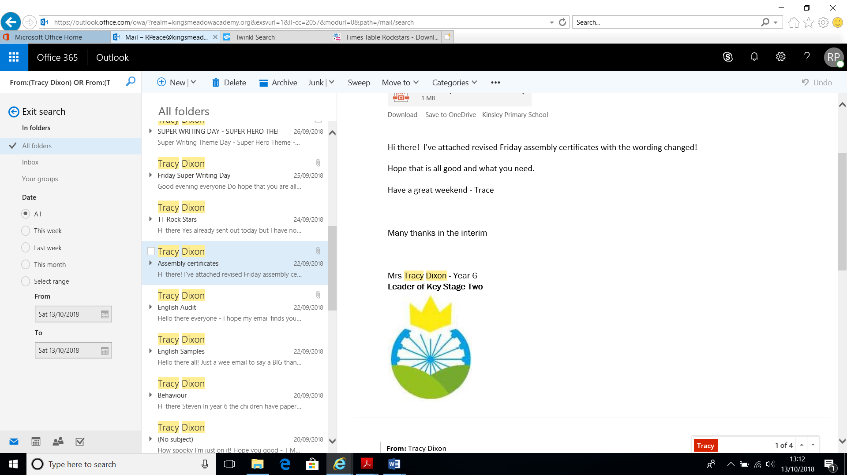

King’s Meadow Academy

Maths Policy

Mathematics is important in everyday life. It is an essential skill that all children will use daily throughout their lifetime. With this in mind, we endeavour to ensure that children develop a healthy and enthusiastic attitude towards mathematics.

Aims

* To foster an enjoyment, fascination and confidence in maths for all children.
* To know by heart number facts such as number bonds, multiplication and related division facts and doubles and halves.
* To ensure all children can make links between mathematical ideas; relate mathematical concepts to the real world and apply these when reasoning and solving problems.
* To have a bank of mental and written methods/skills that they can draw upon and use when necessary.
* To ensure all children are able to achieve and are challenged appropriately.
* To ensure children develop their mathematic vocabulary so they can understand concepts and explain their reasoning.

Teaching

* In order to achieve our aims, all staff will teach to the Primary Maths National Curriculum, using the NCETM Prioritisation documentation to support planning.
* All children will have 1 maths session per day. Minimum of 45 minutes.
* In addition to the maths session, all children will take part in a daily 10/15-minute fluency session (number bonds, multiplication and division facts, doubles and halves). To support this, Years 1 and 2 use Mastering Number at KS1, Year 3 consolidate Mastering Number at KS1 and move onto multiplication booklets, Years 4 and 5 use Mastering Number at KS2 and Year 6 use assessments to identify and plug gaps as needed.
* In EYFS, maths will be taught daily as part of a focus, discrete teaching activity. Children will then be provided with learning activities based upon this teaching, so that they can refine and develop their knowledge and start to apply their skills.
* EYFS use the Mastering Number programme 4x per week and use White Rose Maths to support planning space, shape and measure 1x per week.
* From Years 2 – 6, at the start of a session, children will take part in a ‘fast 5’ activity (5 minutes) to ensure previous learning is regularly revisited.

Books

* Each session will have the date and the title written at the top of the page. Children will miss one line after their title and start their work.

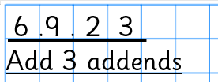

* ‘Fast 5’ will be completed under the date and title, then ruled off ready to start the main part of the session.

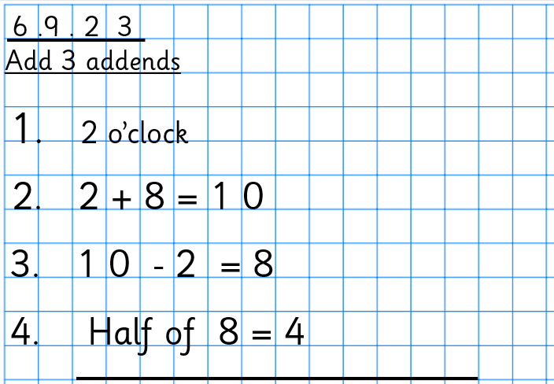

* Numbers will be written one digit per square. After each question number, children will put a . and miss a square. Children will also leave one line between each new question / answer.

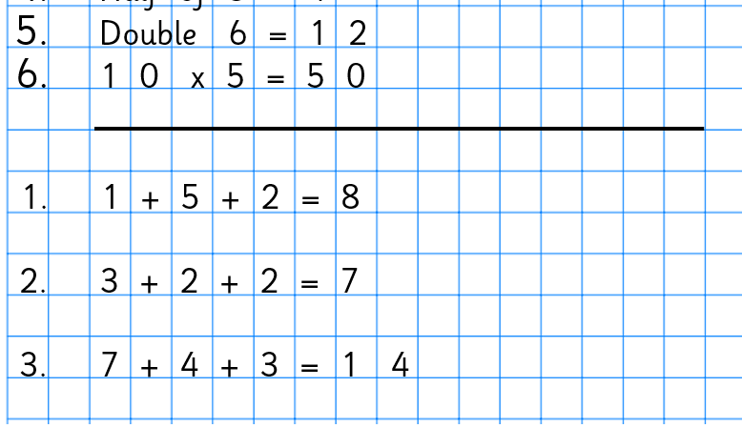

* Sessions will show evidence of concrete-pictorial-abstract working where appropriate (see calculation policy) demonstrating progress through a concept. There should also be evidence of reasoning and problem solving within each objective for all groups of children.
* When necessary, worksheets will be stuck to the left-hand side of the page and children will complete their working out on the right-hand side of the page. Where the sheet is too large for workings to be completed on the right-hand side of the page, it will be completed underneath.
* Worksheets will all have a dot, dash border surrounding them.
* Work will be marked following the marking policy. Active marking will take place where possible to ensure children’s misconceptions are addressed and their learning is moved on.
* Teachers will mark work in a purple pen. Incorrect work should be corrected by the child in a turquoise pen.

Assessment

* Throughout school, teacher’s formative assessment should be the main form of assessment, this should take place throughout each session so children can be challenged effectively.
* Formative assessment should impact on the following days planning to ensure children’s needs are met.
* Standardised assessments will also take place in line with the rest of MAT schools.

Classroom environment

* Mathematical vocabulary related to the current area of learning must be displayed on the working wall and referred to so that the children are immersed in it.
* Other supporting materials to support children must be displayed on the working wall so that they can refer to it during sessions.
* In EYFS, children have the opportunity to apply skills and embed knowledge through planned activities that are set up in both the indoor and outdoor areas.

Homework

* All children from Year R – Year 2 must be set weekly Numbots challenges related to the mathematical topic that they are working on.
* All children from Year 3 upwards (and towards the end of Year 2 where appropriate) must be set weekly TT Rock Stars challenges related to the timetables that they are working on.

*Date written: September 2024 This policy will be reviewed and updated July 2025*