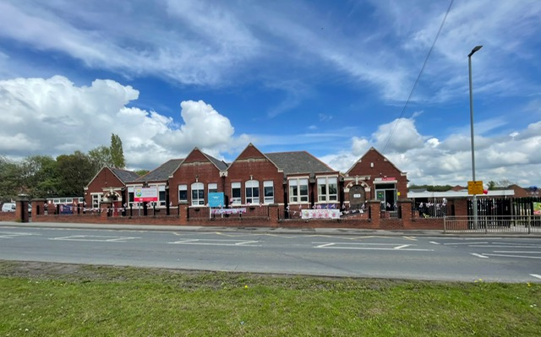

# History Curriculum Overview

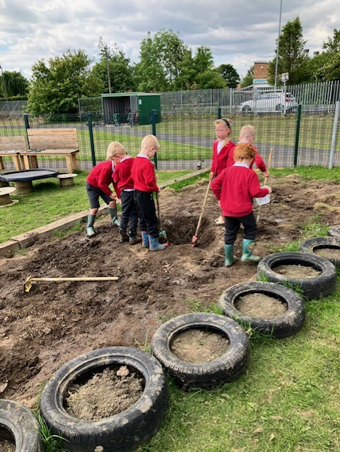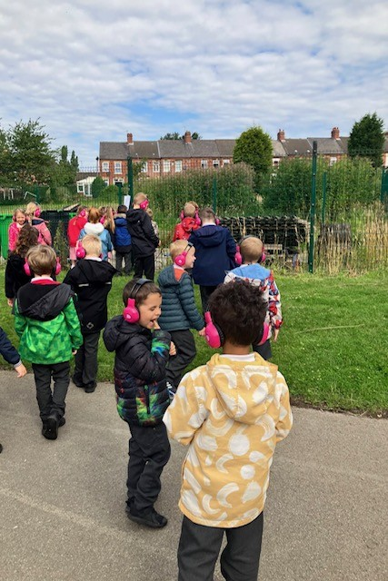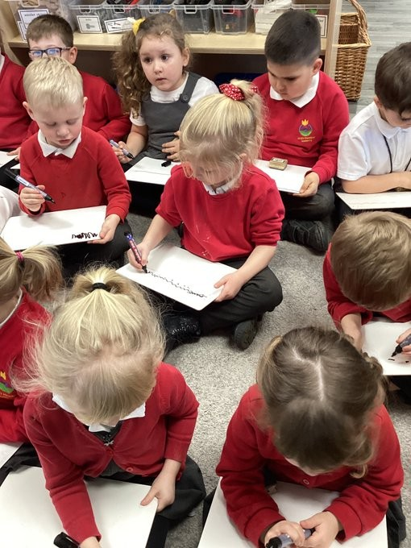

***“Happy children who are confident, independent and thoughtful.”***

# **Our Curriculum Design**

Throughout history mistakes have been made and perspectives differ. As historians, it is vital that we recognise this and use it to understand that to progress in our own learning, mistakes can be made along the way. Our history curriculum is designed to inspire children by promoting the curiosity to explore and engage with the past, learning significant aspects of the wider world alongside the history Britain and our local area. When used correctly, history helps pupils understand the complexities of people’s lives, the process of change, the diversity of societies and relationships between different groups, as well as known identity and challenges of time.

Ultimately, our objective is to cultivate thoughtful, informed citizens who understand the past's relevance to their present and future.

**Our Big Ideas**

Our curriculum is designed to enable our children to work towards an understanding of the ‘big ideas’ in history outlined below by the end of KS2. This cumulative knowledge is developed over time to enable pupils to develop a secure understanding of our 4 identified overarching substantive concepts as identified below.

By the time a child reaches Y6 we expect them to know:

1. Timelines sequence historical events in a chronological narrative from the earliest time to the present day.
2. Historical sources create a ‘picture’ of the past and present the viewpoints of the authors.
3. The names of a range of men and women, who have contributed to national and international achievements that have left a legacy.
4. Stone Age /Iron Age tools and other crafts improved aspects of everyday life including farming techniques.
5. Roman ingenuity changed how people lived, including how roads and towns were built.
6. Ancient civilisations, such as the Ancient Egyptians, Ancient Sumer, Benin, and Indus Valley have left a legacy and influenced the world over the last 5000 years.
7. Ancient Greek achievements have influenced the wider world, e.g. the English alphabet/language, democracy, and significant sporting events/Olympic Games.
8. The Second World War was a crucial turning point in British history and changed the political landscape across Europe.

|  |  |  |  |
| --- | --- | --- | --- |
| **Power (**5)  (monarchy, government & empire)  Lightning bolt with solid fill | **Movement** (4)  (invasion, settlement & migration)  Transfer with solid fill | **Society/Civilisation** (6)  (social & cultural)  Users with solid fill | **Legacy** (6)  (achievements/follies of humanity)  Open hand with plant with solid fill |

In each unit, the overarching substantive concept is explicitly linked to with aspects of other concepts intertwined throughout the unit.

**Our Learning Cycles**

Below is an overview of our unit titles, which are colour coded to show the overarching substantive concept that pupils make prior knowledge links to.

|  |  |  |  |
| --- | --- | --- | --- |
|  | AUTUMN | SPRING | SUMMER |
| EYFS | **Living Memory**-Who am I  Society/ Civilisation | **Living Memory**-What do we know about the royal family? (legacy) | **Significant People & Events –** Important historical figures |
| Y1/2A | **Living Memory**-How am I making history? (society) | **Living Memory**-How have toys changed? (society) | **Beyond Living Memory**-The Great Fire of London (legacy) |
| Y1/2B | **Local Study**-How has KMA changed overtime? (society) | **Significant People/Events**-How did we learn to fly?  (Movement) | **Significant People**-What is a Monarch? |
| Y3/4 Cycle A | **Changes in Britain**-Stone Age, Bronze Age & Iron Age (3500BC-AD) (legacy) | **Early Civilisations Study**-Egyptians (3100BC-332BC)  (Society) | **Why did the Romans settle in Britain?** - The Roman invasion & resistance (AD43-AD440) |
| Y3/4 Cycle B | **Settlement in Britain-** How hard was it to invade and settle in Britain? (Picts, Scots & Anglo Saxons AD450-1066) (movement) | **Ancient Greece Study**- What did the Ancient Greeks do for us? (1200BC-146BC) (legacy) | **The Struggle for the Kingdom of England-** Were the Vikings raiders, traders or settlers? (793-1066)  (movement) |
| Y5/6 | **Who were the Tudors?** -Tudors (1485-1603) | **Non-European Society**-The Benin Kingdom (society) | **Local Study-**Industrial Revolution (legacy) |
| Y6  (KS2) | **British History Study Beyond 1066-Impact of WW2 on British People (1939)** | **Local Study- How has coal mining impacted our region? (1970)** | **British History Study Beyond 1066**-How can we use the Census to find out about the past? |

|  |  |  |  |  |  |  |  |  |  |
| --- | --- | --- | --- | --- | --- | --- | --- | --- | --- |
| **YR** | | | **Autumn** | | **Spring** | | | | **Summer** |
| **Knowledge & Skills** | | | **Living Memory-How am I making history?**   * Photographs can be ordered on a timeline. * Some memories are special. * Special events are remembered. * Childhood was different for our own parents/grandparents. * I am making history. | | **Living Memory - What do we know about the royal family?**   * The Royal family - who are they and what do they do * Name King Charles as our king. * Name **significant people** with a look at King Charles and his achievements. * Start to understand what the monarchy is. * Compare figures from the past * The way that people lived in the past is not the same as the way that we live now. There have been changes to schools, play activities, toys, food, transport and clothes. | | | | **Beyond Living Memory – important historical figures**   * Talking about the lives of the people around them and their roles in society * Knowing some similarities and differences between things in the past and now, drawing on their experiences and what has been read in class. * Objects from the past can look different to objects from the present. |
| **Key People** | | | **Parents/carer & immediate family** | | **Look at a range of important historical figures including members of the monarchy to explore different people and communities (King Charles III & Queen Elizabeth II)** | | | | **David Attenborough, Greta Thunberg, Steve Irwin** |
| **Vocab** | | | **Living memory**, past, present, now, childhood, remember, living memory, **similarity, difference, time capsule**, **future,** change, continuity. | | Apply previously used vocabulary to other people’s lives  Old, older, oldest, parents, grandparents, relatives, mum, dad, sister, past, present, change, order, baby, child, age, before, yesterday, last week, last year  Introduce: King Charles III, Queen Elizabeth II, royal, queen, king, Buckingham Palace, London, now, past, present, then, after that, first, next, timeline, photography, compare, difference, similarity, same, castle, crown, king, prince, princess, queen, royal | | | | Applying previous term’s vocabulary:  Environment, similar, different, society, protect, pollution, ocean, climate, gases |
| **Continuous Provision** | | | * PSE/RE work linked to families, days of the week, months, using vocabulary linked to chronology. * Access to a range of texts and photographs from now and then to start to undertake simple comparisons. * Opportunities in role play and construction/small world to recreate events in the past/present to use key vocabulary. * Access to stories and non-fiction texts both adult/child led to investigate life now and before they were born in terms of family members experiences | | | | | | |
| **Y1** | | | **Autumn** | | **Spring** | | | | **Summer** |
| **Knowledge & Skills** | | | **Living Memory-How am I making history?**   * Photographs can be ordered on a timeline. * Some memories are special. * Special events are remembered. * Childhood was different for our own parents/grandparents. * I am making history. | | **Living Memory & Beyond-How have toys changed?**   * Some toys are special. * Our Grandparents played with toys too. * Within living memory, toys have changed. * We can compare toys from today with toys from the past. * Teddy bears have changed over time. | | | | **Events Beyond Living Memory-The Great Fire of London**   * London was very different to how it is now in 1666. * There was a huge fire in London on 2nd September 1666. * The fire spread very quickly because London was flammable. * After the fire, London was left in ruins. * London was rebuilt over time after the GFOL. * The GFOL left a legacy on the city of London. |
| **Key People** | | | **Own family members** | | **Ole Kirk Christiansen** | | | | **Sir Christopher Wren & Samuel Pepys** |
| **Vocab** | | | **Living memory**, past, present, now, childhood, remember, living memory, **similarity, difference, time capsule**, **future,** change, continuity. | | artefact, century, **decade,** **different,** **evidence**, **living memory,** **memory,** modern, **now**, **past**, present, **remember**, **simila**r, source, special | | | | Century, plague, Stuart, source, Samuel Pepys. evidence, interpret, Lord Mayor, diary, significant, Samuel Pepys, archeologist  evidence, Christopher Wren, King Charles II, legacy |
| **Y2** | | | **Autumn** | | **Spring** | | | | **Summer** |
| **Knowledge & Skills** | | | **Beyond Living Memory-How has KMA changed over time?**   * Our school was different in the past. * Within living memory, our school has changed * KMA different when it first opened. * We can compare our classroom to a classroom when KMA opened. * We can use facts learnt to decide about the past. | | **Significant Events-How did we learn to fly?**   * The Wright Brothers invented the first aeroplane. * The first test flight was in 1903. * Amy Johnson was one of the first female aviators. * We can compare the Wright Brothers and Amy Johnson. * Planes were different in the past. * Air travel in the past to today can be compared to air travel today**.** | | | | **Beyond Living Memory-What is a Monarch?**   * A monarch is the leader of a country. * King Charles III is our monarch today. * William the Conqueror became king of England after winning a battle. * William the Conqueror had absolute power in England. * William the Conqueror and Charles III had different powers as monarchs |
| **Key People** | | | **Mr Gough** | | **The Wright Brothers, Amy Johnson** | | | | **William the Conqueror**  **King Charles III** |
| **Vocab** | | | Date, similar, different, modern, **timeline, past,** present, living memory, past, present, **decade, source,** strict, chalk, George V, coal stove, **beyond living memory,** source, evidence, decade, **modern, slates,** technology, **prefer** | | beyond living memory, flight, **inventor, past,** present  **achievement, significant, aviator,** record, **solo,** cause, consequence, **similarity, difference** | | | | **monarch, Government, significance, coronation**  **ceremony, Absolute monarch, conquer,** battle, Bayeux Tapestry, Harald Hardrada, Primary source, **power, Constitutional monarchy,** Parliament, executive power, similarity, difference |
| **Y3 (A)** | | | **Autumn** | | **Spring** | | | **Summer** | |
| **Knowledge & Skills** | | | **Changes in Britain-Stone Age to Iron Age**   * Life was very different in the Paleolithic and Mesolithic periods * In the Mesolithic period, people had to adapt to live in warmer conditions. * The Stone Age had 3 periods – Paleolithic, Mesolithic and Neolithic. The Bronze Age started after the Neolithic part of the Stone Age. * After the Bronze Age came the Iron Age. * A hillfort was an important building during the Iron Age. * Humans have been present in Yorkshire for at least 10,000 years. | | **Early Civilisations Study-Who were the ancient Egyptians?**   * There are four civilisations that are believed to be the earliest. * The earliest civilisations shared similarities. * The river Nile was important to Ancient Egypt. * Hatshepsut was a significant pharaoh. * Ancient Egyptians believed in the afterlife. * We can use sources of evidence to find out about Tutankhamun. | | | **The Roman Empire and its impact on Britain**   * Romans invaded Britain from 43AD. * Romans had reason to invade Britain. * The Romans had a strong, successful army. * Boudicca rebelled against the Romans. * The Ivory Bangle Lady migrated to Roman Britain. * Romans changed life in modern Britain. | |
| **Key People** | | | **Hunter Gatherers** | | **Tutankhamen, Hatshepsut, Howard Carter** | | | **Julius Caesar, Boudicca, The Ivory Bangle Lady** | |
| **Vocab** | | | Excavation, artefact, prehistory, Doggerland, continuity, mine, ore, alloy, iron ore, bronze, deposit, palisade, granary, ditch, harpoon archeologist. | | **Ancient** Egypt, Indus Valley, Sumer, Shang Dynasty of Ancient China, permanent, **Civilisation,** river, building, writing, city, farming, religion, **society, civilization**, **trade, River Nile,** agriculture, trade, transport, fishing, papyrus, spear, cause, **consequence,** pharaoh, Hatshepsut, architect, trade, **temple,** source, evidence. Significant, **power,** pyramid, tomb, **sarcophagus, m**ummy, embalm, evidence, significant, Howard Carter, **archaeologist,** Tutankhamun, Sarcophagus, artefacts | | | **military,** battle, discipline, order. Empire, **significance,**  Power, Boudicca, King Prasutugus, **tribes,** Iceni. Cassius Dio, primary source. secondary source, i**nference, Military**  discipline. order, centurion, legion, testudo, training, equipment, battle formation, **significance,** power, **Boudicca,** King Prasutugus, **tribe,** Cassius Dio, cause, consequence, York, **ivory,** grave, jet, descent, analyse, infer, **artefacts, legacy** | |
| **Y4 (B)** | | | | **Autumn** | | | **Spring** | | | **Summer** |
| **Knowledge & Skill** | | | | **Changes in Britain-Anglo-Saxons, Picts & Scots**  **How hard was it to invade and settle in Britain?**   * The Anglo-Saxons and the Scots invaded Britain. * The Anglo-Saxons settled in Britain. * We can learn about Anglo-Saxon society from Sutton Hoo. * Alfred the Great defended Britain against the Vikings. * Alfred the Great encouraged peace in England. * The Anglo-Saxon period ended in 1066. | | | **Ancient Greece Study-What did the Ancient Greeks do for us?**   * Excavations can tell us a lot about what life was like in Early Greece. * Minoans traded things in Early Greece. * Life in Sparta and Athens had similarities and differences to life today. * The city-states of Sparta and Athens had to overcome attacks from Persia. * Alexander the Great was a significant leader. * The ancient Greeks achieved great things | | | **The Struggle for the Kingdom of England-Were the Vikings raiders, traders or settlers?**   * Sources of evidence can be used to challenge Viking stereotypes. * The Vikings gained a bad reputation. * The Vikings first came to Britain to raid. * Recent excavations have changed our view of the Vikings. * People have different views about the Vikings. |
| **Key People** | | | | **King Alfred the Great** | | | **Alexander the Great** | | | **Edward the Confessor, King Ethelred** |
| **Vocab** | | | | **Angles, Saxons,** Jutes, invasion, Romans, longships, chronology, sequencing, defeated, **kingdom,** Anglo-Saxon, Jute, **settlement,** village, **burial mound,** longboat, garnet  , gilt, Riedewald, sceptre, Battle of Edington, creator, Danelaw, Guthrum The Great Heathen Army  Vikings Wessex, bias, evidence, **primary source, secondary source,** Wessex, bias, evidence, **primary source, secondary source,** William of Normandy  Harald Hardrada, Harold Godwinson, Earl of Wessex, oath, exile, claimant, Wessex, Normandy, Witan, **successor, significance** | | | social structure, society belief, theatre, trade, vote, warfare, writing. city state, collapse, colony, conquer, control, council, councilor, debate, democracy, dynasty, exile, gender, general, government, hierarchy, jury, league, lower class, middle class, monarchy, power, priest, priestess, Parthenon, achievement, ancient Greece, ancient Sumer, Archaic, Bronze Age, Classical, Dark Age, democracy, education, fashion, ethics, government | | | **Angles, Saxons,** Jutes, invasion, Romans, longships, chronology, sequencing, defeated, **kingdom,** Anglo-Saxon, Jute, **settlement,** village, **burial mound,** longboat, garnet  , gilt, Riedewald, sceptre, Battle of Edington, creator, Danelaw, Guthrum The Great Heathen Army  Vikings Wessex, bias, evidence, **primary source, secondary source,** Wessex, bias, evidence, **primary source, secondary source,** William of Normandy  Harald Hardrada, Harold Godwinson, Earl of Wessex, oath, exile, claimant, Wessex, Normandy, Witan, **successor, significance** |
| **Y5** | | | | **Autumn** | | | **Spring** | | | **Summer** | | | |
| **Knowledge & Skills** | | | | **Who were the Tudors?**   * The Battle of Bosworth marked the start of the Tudor period. * We can interpret evidence to find out about Henry VIII. * Henry VIII had six wives! * Elizabethans had reasons to explore the world. * Elizabethans enjoyed different sport and leisure activities? | | | **Non-European Study- Kingdom of Benin**   * We can place key events of the Kingdom of Benin on to a timeline. * We can use sources of evidence to learn about the Benin Kingdom. * Europeans wanted to trade with Benin. * Changes contributed to the decline of Benin. * Benin appealed to the British. * The British Museum still hold on to items from the Benin Kingdom. | | | **The Industrial Revolution**   * The Industrial Revolution was a period of significant change in Britain, transforming industries and everyday life. * West Yorkshire played a crucial role in the Industrial Revolution due to its resources and industries. * Working conditions in mills and factories were often harsh and unsafe. * The development of canals, railways, and roads transformed West Yorkshire’s economy and society. * The Industrial Revolution brought both progress and challenges to people in West Yorkshire. * The Industrial Revolution has had a lasting impact on West Yorkshire's culture, economy, and infrastructure. | | | |
| **Key People** | | | | **Henry VIII, Anne Boleyn, Elizabeth I, Sir Francis Drake** | | | **Oba Ewuare, Oba Ozolua & Oba Esigie** | | |  | | | |
| **Vocab** | | | | Tudor, House of Lancaster, House of York, Battle of Bosworth, War of the Roses, timeline, BC (before Christ), AD (Anno Domini), chronology, time-period, century, **concurrent, monarch,** Henry VIII  **Tyrant,** ruler, monarch, portrait, evidence, fair, **interpretation,**  primary source, bias, reliable, behead, **heir,** cause, **consequence,** exploration, **slavery,** new world, protestant, blood sports, monarch, **trade, power,** Royal Mail, spy, assignation, colony, significance, evaluate, analyse, **conclude** | | | **Kingdom,** Benin, Nigeria, Edo, Oba, Golden Age, Europe, Timeline, Period, **Concurrent,** temple bell, skilled , ivory, copper, spiritual, Benin Bronzes, **Oral history, a**rtefacts, **deduce,** Golden era. **Ivory,** pepper, rubber,slaves, **trade,** Society , continuity, change, Plaques/sculptures, metal, **Civil War,** slavery , **abolish,** change, continuity | | | Industrialisation, revolution, textiles, mills, Factory, child labour, economy, socjety, urbanisation, tenements**.** | | | |
| **Y6** | | | **Autumn** | | | **Spring** | | | **Summer** | | | |
| **Knowledge & Skills** | | | **Local Study-The impact of WW2 on Children**   * Before World War 2, Hitler came to power and became the leader of Germany. * The Second World War began in 1939. * Britain had to react to the outbreak of WW2. * The lives of civilians were changed dramatically during WW2. * Britain’s Home Front faced several challenges when it came under attack. * World War 2 had a major impact on our Yorkshire region. * Major victories on the battlefield led to Britain winning the war. | | | **How has coal mining impacted our area?**   * Key events can be placed onto a timeline. * Miners worked in dangerous conditions. * The Kinsley evictions are an important story in our local history. * The 1984 miners’ strike impacted our area - Origins of the strike. * The 1984 miners’ strike impacted our area - The Battle of Orgreave. | | | **Local Study-What does the census tell us about our local area?**   * The census is used to find out about people living in the past. * The Census is used to investigate the lives of individuals. * Historians use a range of sources to find out about the past. * Some women refused to complete the 1911 census. * The census gives information about our area. | | | |
| **Key People** | | | **Anne Frank, Alan Turing, Winston Churchill & Neville Chamberlin** | | | **Margaret Thatcher, Arthur Scargill, Thomas Elstone, Earl of Fitzwilliam** | | | **Mary Bucktrout, The Suffragettes** | | | |
| **Vocab** | | | World war, axis, allies, Adolf Hitler, Nazi party, invade, pact, the blitz (Blitzkrieg 'Lightning war') air raid, rationing, blackout, gas mask, code breaking, enigma code, propaganda, declare war, expand, empire, Winston Churchill, air raid shelter | | | Kinsley evictions, Colliery (Hemsworth and Fitzwilliam), Kinsley Drift, Miner’s strike, **chronology,** timeline, BC/AD, time period, century, **concurrent, Industrial revolution,** community, coal  society, Earl of Fitzwilliam, significance, change, explosion  exploitation, conditions, **Government,** legislation, **Power,** change, continuity, **strike,** dispute, eviction order, protest, bell tents, Kinsley Hotel, Thomas Elstone, cause , **consequence,** Thatcher, Scargill, **riot, s**trike, police, **impact** | | | Census. enumerator, schedule, enumeration books, head of household, condition (marital status), Evidence, primary source, **infer,** Flax Spinner, lodger, textiles, **Inference**  observe, textile mill, flax, yarn, **carding,** William Dodd. **Shilling, boycott, Suffragette,** protest. Suffrage, movement, cause, consequence, | | | |

**Our Disciplinary Knowledge Progression**

|  |  |  |  |  |  |  |  |
| --- | --- | --- | --- | --- | --- | --- | --- |
|  | **EYFS** | **Y1** | **Y2** | **Y3** | **Y4** | **Y5** | **Y6** |
| **Historical Period** | **My family:** Who am I?  **My past:** What do we k now about the royal family and what was different in the past? | **Within Living Memory:** How have toys changed and how am I making history?  **Beyond Living Memory:** What is a Monarch?  **Key Figures in History:** How did we learn to fly? William the Conqueror & Amy Johnson  **Local History:** How was school different in the past? | | **World History- Ancients beyond 3,000 years ago**: Early Civilisations, Ancient Egypt  **British History- Stone Age to 1066:** The Stone Age, The Romans, The Anglo Saxons and Vikings  **World History- Non- European Society:** The Kingdom of Benin  **World History-** Ancient Greece  **British History- Beyond 1066:** The Tudors**.** World War 2,  **Local History:** The Industrial Revolution, Census, coal mining | | | |
| Progression of skills and knowledge | | | | | | | |
| **Key Area** | **EYFS** | **Y1** | **Y2** | **Y3** | **Y4** | **Y5** | **Y6** |
| **Change and continuity** | Beware of changes that happen throughout the year (e.g. seasons, nature).  To know that the environment around us changes as time passes. | Being aware that some things have changed and some have stayed the same in our own lives.  Describing simple changes and ideas/objects that stay the same.  Understand that some things change while other items remain the same and some are new.  To know that people change as they grow older.  To know that throughout someone’s lifetime some things eill change and some things will stay the same.  To know that everyday objects have changed over time. | Recognise that some things which have changed/stayed the same in the past.  Identifying simple reasons for changes.  To know that daily life has changed over time, but that there are still some similarities to today. | Identifying reasons for change and reasons for continuities.  Identifying what the situation was like before the change occurred.  Comparing different periods of history and identifying changes and continuity  To know that change can be brought about by advancements in trade. | To know that change can be brought about by advancements in transport and travel.  Identifying the links between different societies.  To know that change can be brought about by advancements in transport and travel | Making links between events and changes across different time periods/societies.  Describing the links between different societies.  Identifying the reasons for change and continuity.  To know that change can be brought about by conflict. | Explaining the reasons for changes and continuity.  Describing the links between main events, similarities and changes within and across different periods studied.  Explaining the reasons for changes and continuity using the vocabulary and terms of the period as well.  Analysing and presenting the reasons for changes and continuity.  To know that change can be traced using the census. |
| **Similarity and difference** | Beginning to recognise similarities and differences between the past and today.  Using photographs and stories to compare the past with the present day. | Beginning to look for similarities and differences over time in their own lives  Beginning to identify similarities and difference between ways of life at different times.  To know that there are similarities and differences between their lives today and their lives in the past.  To know some similarities and differences between the past and their own lives.  To know that people celebrate special events in different ways.  TO know that everyday objects have similarities and differences with those used for the same purpose in the past. | Identifying similarities and difference between ways of life at different times.  Finding out about people, events, and beliefs in society.  Making comparisons with their own lives.  To know that there are explanations for similarities and differences between children’s lives now and in the past.  To know some similarities and differences between the past and their own lives. | Begin to describe similarities and differences between periods of history. | Explaining similarities and differences between daily lives of people in the past and today.  Begin to identify similarities and differences between social, cultural, religious diversity in Britan and the wider world. |  | Describing similarities and differences between social, cultural, religious and ethnic diversity in Britain and the wider world.  Making links with different time periods studied. |
| **Sources of evidence** |  | Use artefact and photographs to ask simple questions about the past.  Finding answers to simple questions about the past using sources.  TO know that photographs can tell us about the past.  To know that we can find out about the past by asking people hwo were there.  To know that artefacts can tell us about the past.  To know that we remember some (but not all)of the events that we have lived through. | Use artefact and photographs to ask questions about the past.  Make simple observations about a source or artefact.  Identify a primary source.  To find out about how places have changed by looking at maps.  To know that historians use evidence from sources to find out more about the past. | Use a range of sources to find out about a particular period.  Use evidence to build up a picture of the past. | Observe smaller details when using artefacts and pictures.  Identify sources which are influenced by the personal beliefs of the author. | Recognise primary and secondary sources.  Use a range of sources to find out about a particular aspect of the past.  To understand the types of information that can be extracted from the census.  To understand some key terms on the census. | Recognise primary and secondary sources.  Use a range of sources to find out about a particular aspect of the past.  Identifying bias in a source and identifying the value/limitations of a source.  Describe how secondary sources are influenced by the culture, beliefs and cultures at the time of the author.  To understand the types of information that can be extracted from the census and how we can use this information.  To understand some key terms on the census.  To know that the most reliable sources are primary sources which were created for official purposes. |
| **Cause and consequence** | Experience the cause and effect in play – achieve through continuous provision. | Asking why things happen and beginning to explain why with support.  To know that everyday objects have changed as new materials have been invented. | Asking questions about why people did things | Identifying the consequences of events and actions of people.  To know that the actions of people can be the cause of change. | To know that the actions of people can be the cause of change.  Identifying the reasons for historical events, situations and changes.  To know that advancements in science and technology can be the cause of change. | Give reasons for historical events, the results of historical events and changes.  To know that members of society standing up for their rights can be the cause for change | Starting to analyse and explain the reasons for historical events, situations and change. |
| **Historical**  **Significance** |  | Recall special events in their own lives.  To know that some people and events are considered more ‘special' or significant than others. | Discuss who was important in a historical event.  Know that some events are more significant than others.  To know the impact on an important event on society.  To know that historically significant people are those who change many peoples lives. | Recall some important people and events.  Identify who is significant in historical sources and accounts. | To know that significant archeological findings which are those which change how we see the past.  To know that we can see inferences and deductions using images from the past. | Identify significant people and events across different time periods.  Compare significant people and events across different time periods. | Explain the significance of events, people and developments.  To know how historians select criteria for significance and that this changes. |
| **Chronological awareness** |  | Sequencing 2/4 events in their own life.  Using common words/phrases for the passing of time e.g. now, ten, long ago.  Sequencing 3to4 photographs/artifacts to show different periods of time.  Placing simple events on a timeline. | Placing a time studied on a timeline.  Sequence 4/6 photographs, focusing on intervals between events.  Placing events on a timeline, building on times studied in year 1.  Beginning to recognise how long each event lasted.  Knowing where people/events studies fit into a chronological framework | Sequencing events on a timeline, referring to times studied in KS1 where these fit in.  Understand that history is divided into different periods of history.  Making a simple individual timeline. | Using BC/AD/Century.  Using dates and terms related to the unit and the passing of time e.g. continuity, ancient  Placing a time studied on a timeline.  Beginning to develop a chronologically secure knowledge of local, British and world history across periods studies on a timeline. | Sequencing events on a timeline, comparing where it fits in with times studied in previous year groups.  Understanding the term ‘century.  Placing the time and period of history into a timeline.  Noticing connections over a period of time | Putting dates in the correct century.  Relating current study on timeline to other periods studies.  Comparing and making connections between different contexts in the past, |
| **Historical Interpretation** |  | Beginning to identify different ways to represent the past e.g. photos/stories.  Developing their own interpretations from historical artefacts. | Recognise different ways in which the past is represented (including eye witness accounts).  Comparing pictures/photos of people or events in the past.  Developing their own interpretations from photographs and written sources | Identify different ways in which the past is represented.  Identify differences between different sources.  Explore different representations of the period. | Identify and give reasons for different ways in which the past is represented.  Identify differences between different sources, giving reasons for the ways which the past is represented.  .  Explore different representations of the period and evaluate the usefulness of the source. | Begin to compare accounts of events from different sources.  Understand that different evidence creates different conclusions.    Devise historically valid questions. | Suggesting explanations for different versions of events.  Compare accounts of events from different sources.  To know that we must consider a source’s audience, purpose and creator to determine if it is a reliable source.  Address and devise historically valid questions. |