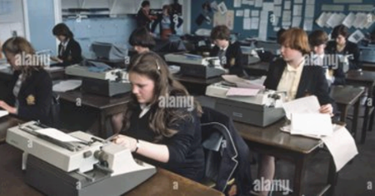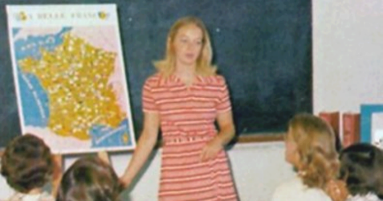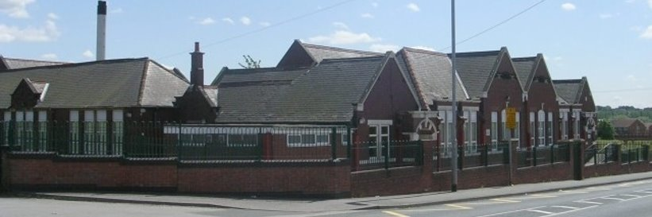

How has life for children at King’s Meadow Academy changed over time?

Knowledge Organiser

**Questions we will ask you and you can ask your family:**

How has school life changed?

Was school life different along time ago?

How is school life similar and different to when your parents / grandparents went to school?

**Key Dates:**

1900s – School experiences from a very long time ago

1950-1960 – School experiences of our grandparents

1980-1990 – School experiences of our parents

2022 – School experiences - me

**Vocabulary you will use:**

* Decade – a period of 10 years
* Century – a period of a hundred years
* Sequence – a particular order in which things happen
* Time period – an amount of time
* Technology – how we use different ways to learn
* Sources – a person/place or thing that you get information from
* Evidence – things you see, hear or are told you believe are true
* Compare – differences and similarities
* Past – Events before today (now)
* Present – Events that are happening now

**Builds on Skills and Knowledge**

In EYFS you learnt about how toys had changed over time

In Year 1 you learnt about Mary Seacole and The Great Fire of London